# SQL Murder Mystery

## Project description

There's been a Murder in SQL City! The SQL Murder Mystery is designed to be both a self-directed lesson to learn SQL concepts and commands and a fun game for experienced SQL users to solve an intriguing crime. This challenge can be found at https://mystery.knightlab.com/

## Start here

A crime has taken place and the detective needs your help. The detective gave you the crime scene report, but you somehow lost it. You vaguely remember that the crime was a **​murder​** that occurred sometime on ​**Jan.15, 2018​** and that it took place in ​**SQL City​**. Start by retrieving the corresponding crime scene report from the police department’s database.

## Exploring the Database Structure

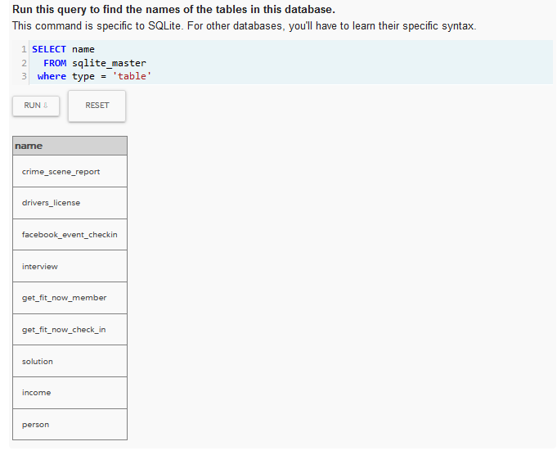

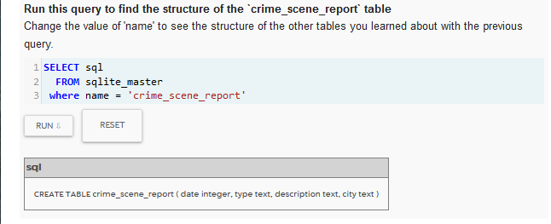

## Read the crime scene report

SELECT *

FROM crime_scene_report

WHERE date = 20180115

AND type = "murder"

AND city LIKE "SQL%";

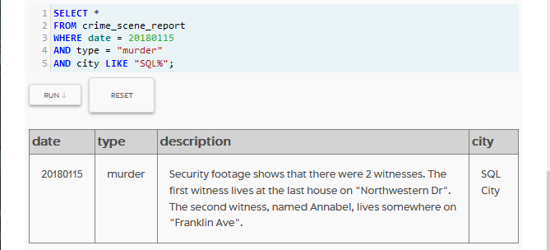

CLUES

Security footage shows that there were 2 witnesses. The first witness lives at the last house on "Northwestern Dr". The second witness, named Annabel, lives somewhere on "Franklin Ave".

## Read the witness interviews

SELECT *

FROM person

WHERE address_street_name = "Northwestern Dr"

ORDER BY address_number DESC

LIMIT 1;

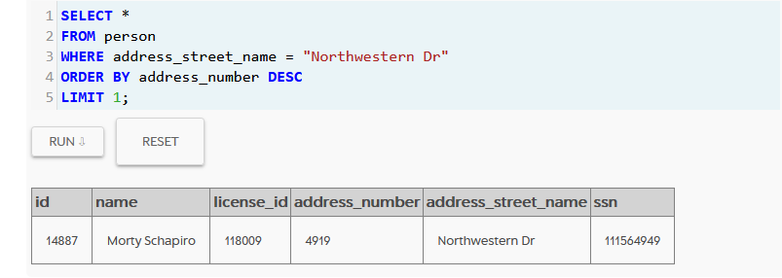

SELECT transcript

FROM interview

WHERE person_id IN

(

SELECT person.id

FROM person

WHERE address_street_name = "Northwestern Dr"

ORDER BY address_number DESC

LIMIT 1

);

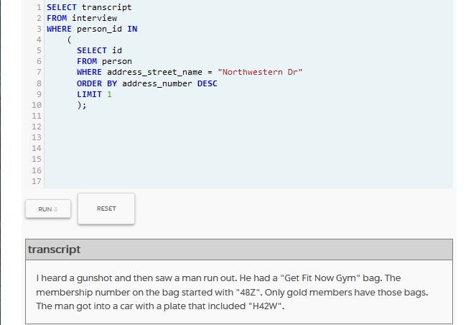

CLUES:

I heard a gunshot and then saw a man run out. He had a "Get Fit Now Gym" bag. The membership number on the bag started with "48Z". Only gold members have those bags. The man got into a car with a plate that included "H42W".

SELECT transcript

FROM interview

INNER JOIN person on person.id = person_id

WHERE address_street_name = "Franklin Ave"

AND name like "Annabel%";

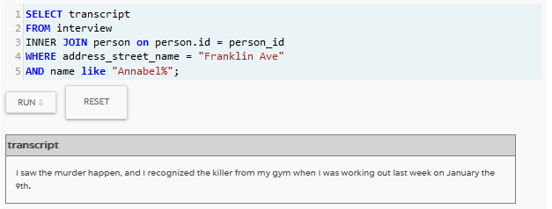

I saw the murder happen, and I recognized the killer from my gym when I was working out last week on January the 9th.

## Find the Suspect

SELECT person.name

FROM person

INNER JOIN drivers_license ON license_id = drivers_license.id

INNER JOIN get_fit_now_member ON get_fit_now_member.person_id = person.id

INNER join get_fit_now_check_in ON get_fit_now_member.id = membership_id

INNER JOIN income ON person.ssn = income.ssn

WHERE plate_number LIKE "%H42W%"

AND membership_status = "gold"

AND get_fit_now_member.id LIKE "48Z%"

AND get_fit_now_check_in.check_in_date = 20180109;

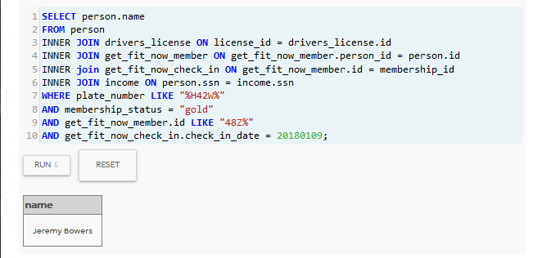

Clue: Jeremy Bowers

## Check Solution

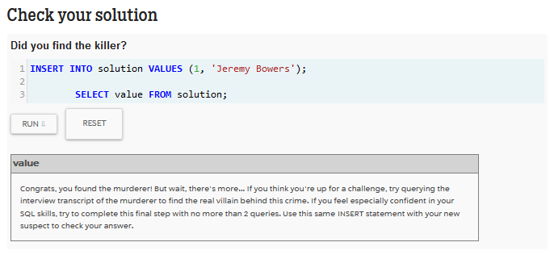

Reveal the Master Mind

SELECT transcript

FROM interview

WHERE person_id IN (

SELECT person.id

FROM person

INNER JOIN drivers_license ON license_id = drivers_license.id

INNER JOIN get_fit_now_member ON get_fit_now_member.person_id = person.id

INNER Join get_fit_now_check_in ON get_fit_now_member.id = membership_id

INNER JOIN income ON person.ssn = income.ssn

WHERE plate_number LIKE "%H42W%"

AND membership_status = "gold"

AND get_fit_now_member.id LIKE "48Z%"

AND get_fit_now_check_in.check_in_date = 20180109);

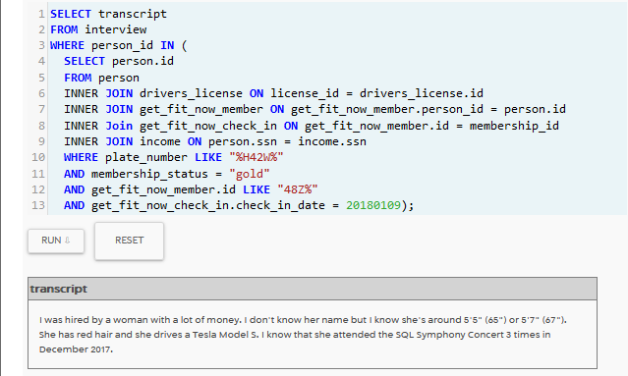

SELECT person.id, person.name, event_name, facebook_event_checkin.date, annual_income

FROM person

INNER JOIN drivers_license ON license_id = drivers_license.id

INNER JOIN facebook_event_checkin on person.id = facebook_event_checkin.person_id

INNER JOIN income ON person.ssn = income.ssn

WHERE height BETWEEN 65 AND 67

and gender = 'female'

AND event_name = "SQL Symphony Concert"

AND car_make = "Tesla"

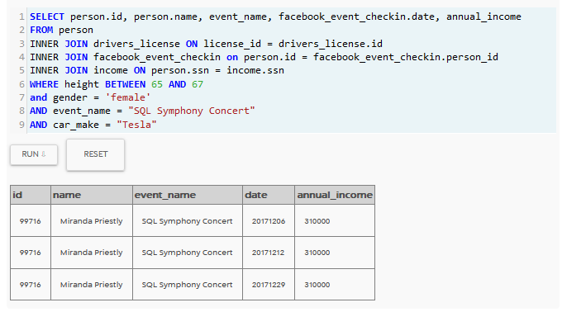

## Summary

In this exercise we solved murder mystery using our knowledge of SQL and Object relational databases to query a SQLITE database finding clues hidden inside and ultimately solving the mystery. We first queried the database to identify its structures, which was in the form of tables. We then identified the schema inside the tables and using this knowledge we queried the database tables using joins and filters to get useful information that was hidden in the database and this helped solve the mystery. It was Jeremy Bowers whodunit!

### Credits

The SQL Murder Mystery was created by [Joon Park](https://twitter.com/joonparkmusic) and [Cathy He](https://twitter.com/Cathy_MeiyingHe) while they were Knight Lab fellows. See the [GitHub repository](https://github.com/NUKnightLab/sql-mysteries) for more information.

Adapted and produced for the web by [Joe Germuska](https://twitter.com/joegermuska).

This mystery was inspired by [a crime in the neighboring Terminal City.](https://github.com/veltman/clmystery)

Web-based SQL is made possible by [SQL.js](https://github.com/sql-js/sql.js/)

SQL query custom web components created and released to the public domain by Zi Chong Kao, creator of [Select Star SQL.](https://selectstarsql.com/)

Detective illustration courtesy of [Vectors by Vecteezy](https://www.vecteezy.com/)

Original code for this project is released under the [MIT License](https://github.com/NUKnightLab/sql-mysteries/blob/master/LICENSE)

Original text and other content for this project is released under [Creative Commons CC BY-SA 4.0](https://creativecommons.org/licenses/by-sa/4.0/)